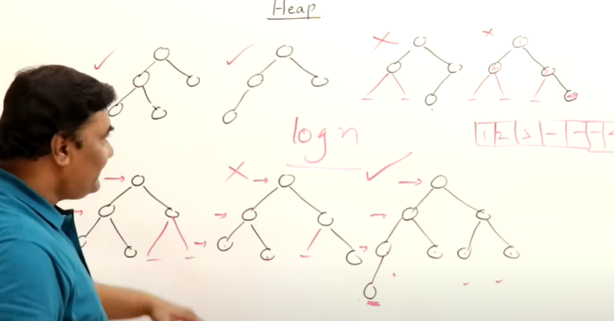

If there is missing element when we convert array to binary tree then that is not a complete binary tree

At each level nodes are, 2^h+1 - 1, like if h is 0 then 2^1 - 1 that is 1 at first level

In a complete binary tree, there should not be gaps when we convert it into array

We will not go to next level until it is filled.

like 1

2 3

1 then 2 then 3, not 1 3 2, so like that

Log n -> height